Site & Route

**Flask**

* What is Flask?
* Flask is a micro web framework written in Python. It is classified as a microframework because it does not require particular tools or libraries. It has no database abstraction layer, form validation, or any other components where pre-existing third-party libraries provide common functions.
* Why Flask is used for?
* Flask is used for **developing web applications using python**, implemented on Werkzeug and Jinja2. Advantages of using Flask framework are: There is a built-in development server and a fast debugger provided.

For implementing Flask we need to keep our knowledge on python and for frontend we need to keep knowledge in Jinja(Jinja is a web template engine for the Python programming language. It was created by Armin Ronacher and is licensed under a BSD License. Jinja is similar to the Django template engine but provides Python-like expressions while ensuring that the templates are evaluated in a sandbox)

We have described our business need for this app and using flask for developing the app

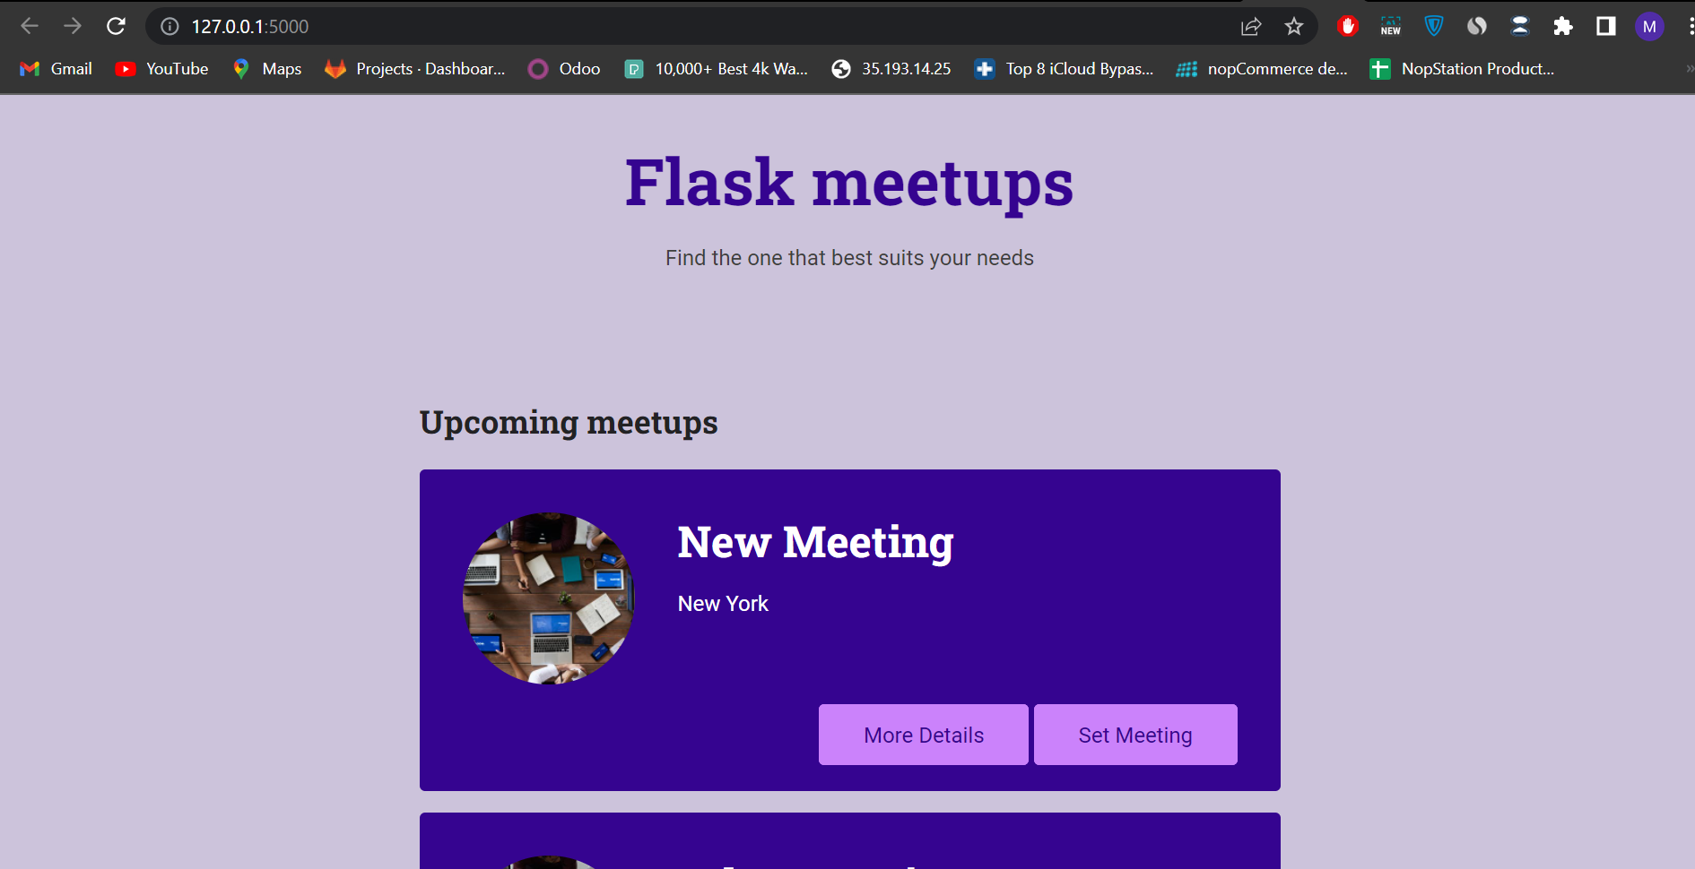

This is our main site, where frontend part is developed by jinja and python in Flask, the main url is 127.0.0.1, we can change our port and url in code.

Routes of our app:

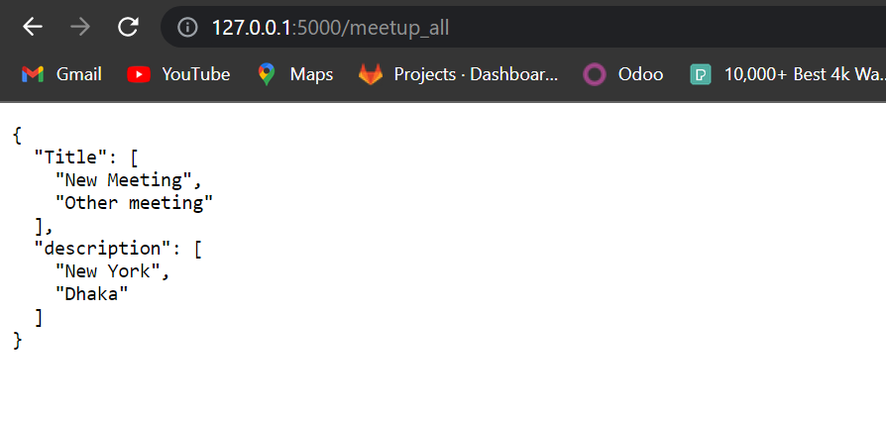

‘/meetup_all’ This route provide the json containing Title and Description from database

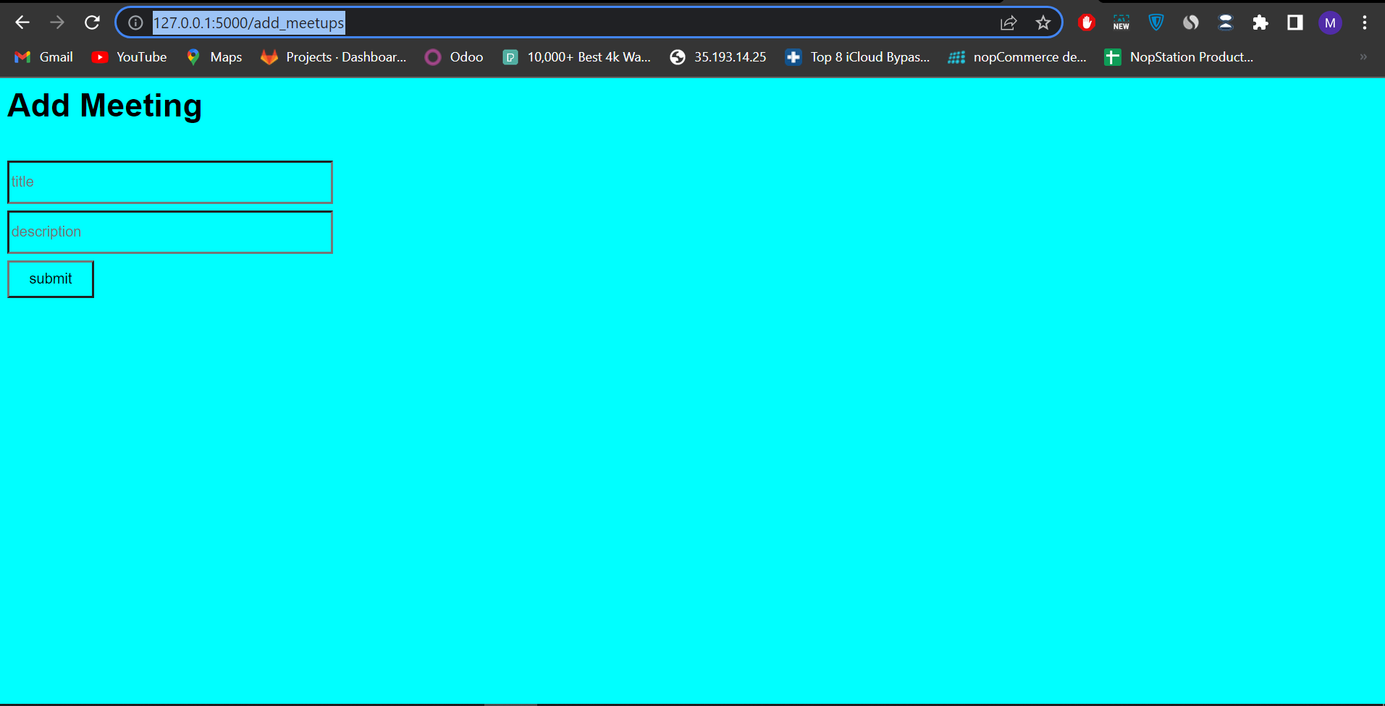

‘/add_meetups’ is using for add new meetup by giving title and description

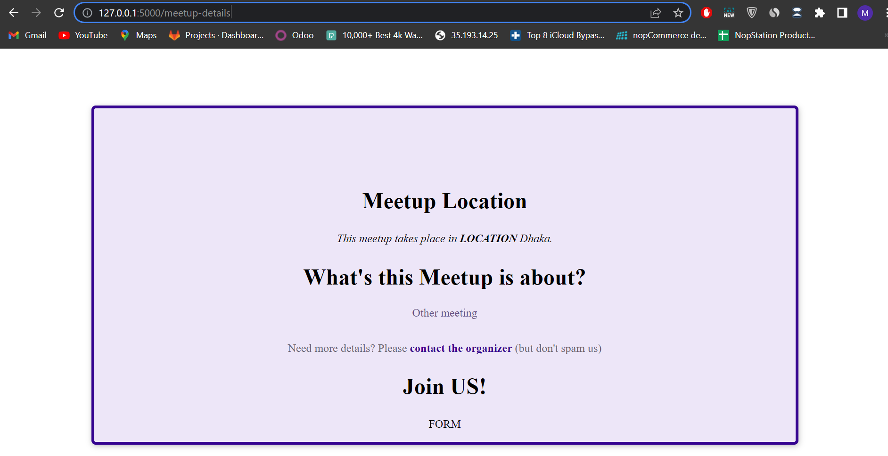

‘/meetup-details’ route is providing the meetup details where title and description fetch up from database,

We use sqlite database for this app

**Django**

* What is Django?
* Django is a Python-based free and open-source web framework that follows the model–template–views architectural pattern. It is maintained by the Django Software Foundation, an independent organization established in the US as a 501 non-profit
* Why Django is used for?
* Django is a high-level Python web framework that **enables rapid development of secure and maintainable websites**. Built by experienced developers, Django takes care of much of the hassle of web development, so you can focus on writing your app without needing to reinvent the wheel.

To implement application using Django we need to keep knowledge on python and Django template language which is used for building the ui(FrontEnd).

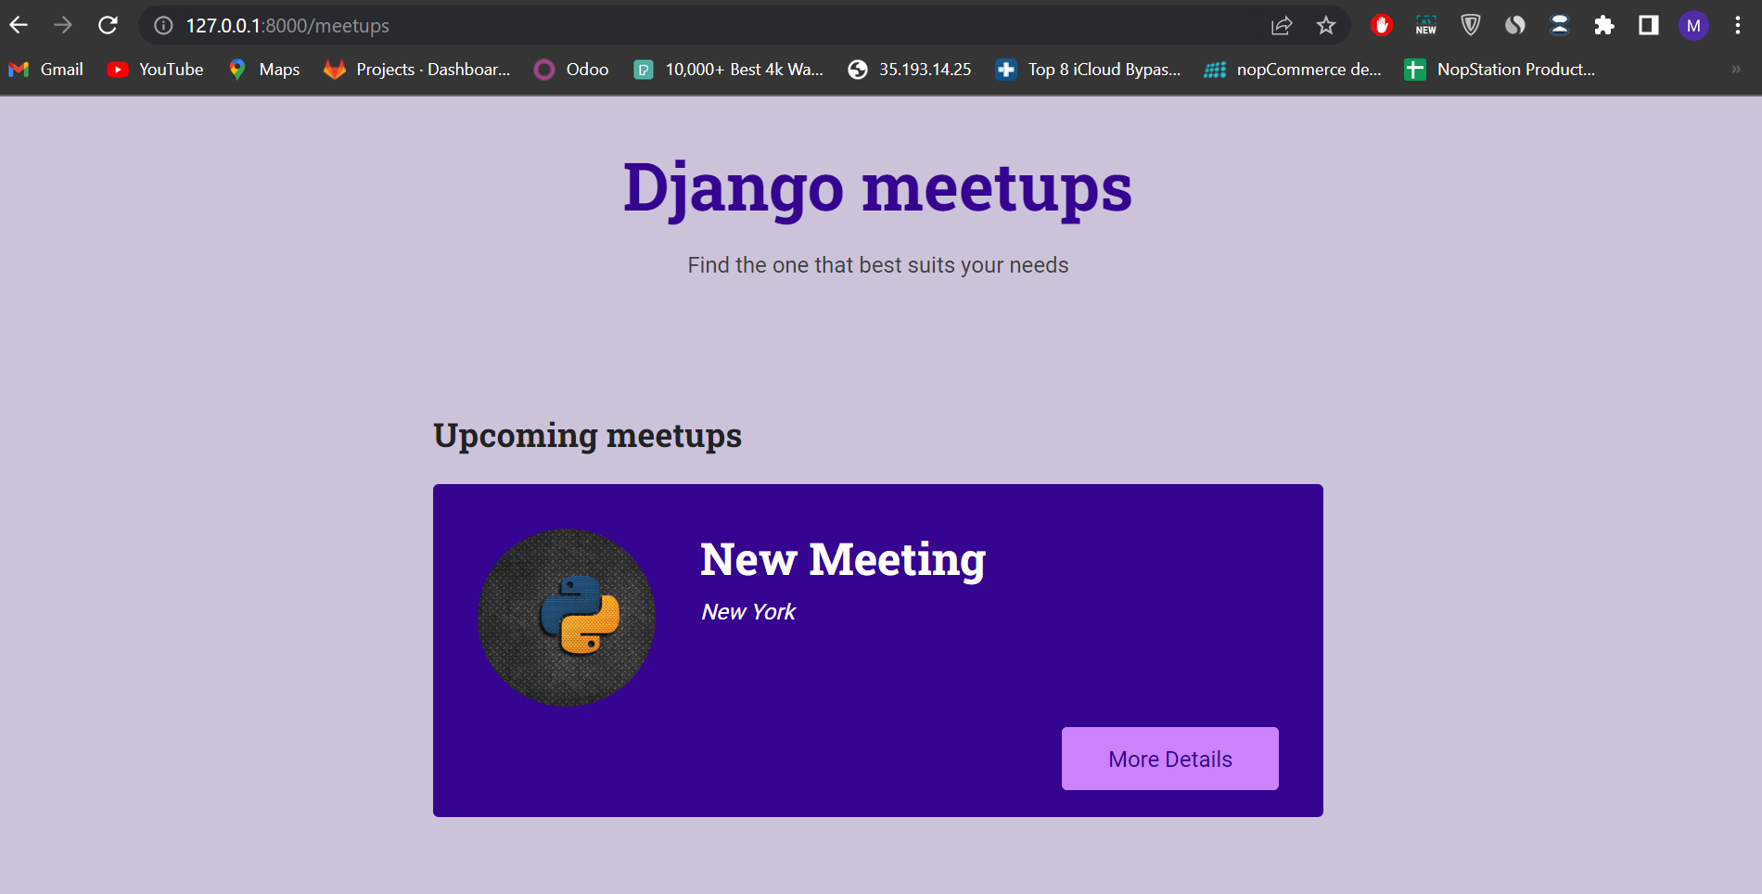

‘/meetups’ this route is the main route path of our application containing the card of upcoming meetings containing in card with title and description and image.

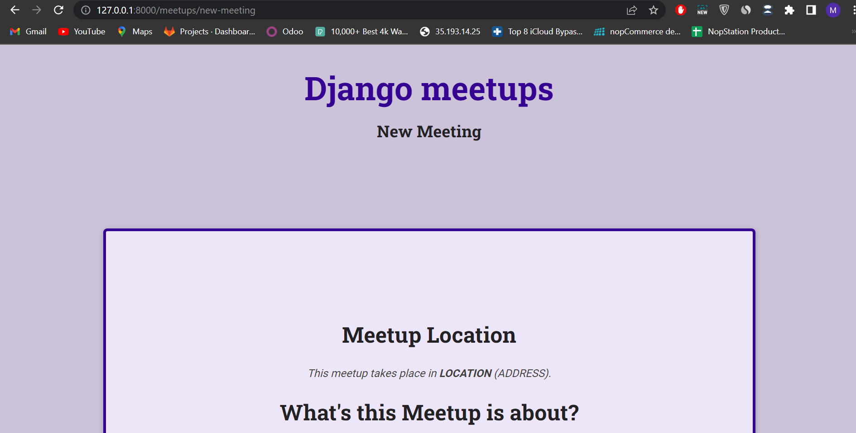

‘/meetup_details/<title_name>’ this routes provides the meetup details of the app

We also use sqlite for Django